

MEMORANDUM

**To: Wolf-Dieter Otte (dieter.otte@nau.edu)**

**From: 1-Hitter Programmers**

**Brian Cullinan**

**Steven Lambright**

**Subject: Capstone Final Report**

**Date: 4/30/2010**

Table of Contents

Introduction 3

1-Hitter Programmers 3

The Problem 3

The Solution 4

Process 4

Methodology 4

Deliverables 4

Progress Reports 4

Team Website 4

Team Inventory 4

Team Standards Document 4

Requirements and Execution Plan 5

Software Design Specification 5

Capstone Poster 5

PowerPoint Presentations 5

Timeline 5

Requirements 5

Implementation 5

Architecture 6

Usability Testing 7

Conclusion 7

Final Report

# Introduction

This is the final report for the AZMLA Web Store capstone project, sponsored by the Arizona Major League Alumni (AZMLA), with Paul Iverson as a primary contact. The team tackling this project is the 1-Hitter Programmers.

# 1-Hitter Programmers

The team originally consisted of:

* Brian Cullinan, the lead developer and team recorder
  + Responsible for maintaining the code base, test platform, and taking and distributing notes from meetings
* Davis Zanot, the team communicator and facilitator
  + Responsible for all electronic communication with the client, coordinating meetings with the client, and resolving disputes
* Steven Lambright, the team leader and lead designer
  + Responsible for keeping the team on track in both goals and meetings, designing the layout or form of the solution, and communicating the design to team members

Our mentor was Dr. Wolf-Dieter Otte. Approximately half way through the semester we lost Davis Zanot, who voluntarily dropped the class. Brian Cullinan took on communications with the client and coordinating meetings.

# The Problem

The sponsor, the Arizona Major League Alumni (AZMLA), receives sports memorabilia from donations made by the public. With no efficient way to profit from the cards and memorabilia, the AZMLA has been profiting only by word of mouth. This hinders the AZMLA’ s mission to:

* Promote the game of baseball
* Involve former major league players in community activities
* Raise funds to support charitable causes

Proceeds from this online store would go to other charitable, baseball-related causes such as the Arizona Youth Baseball Program, which teaches good sportsmanship to our children. Proceeds would also go to annual celebrity baseball dinners. The project was proposed as creating an online store for the AZMLA, however we, 1-Hitter Programmers, decided to widen the scope of the project to encompass re-launching the entire AZMLA website.

# The Solution

The re-launched website is based on the Drupal (www.drupal.org) content management system; it features fully dynamic content, an online store, an interactive calendar and more.

## Process

The process used to come up with the solution had several strong points and weak points. We picked sections to work on weekly and went about our tasks. When areas overlapped, the task was given to one developer and the other picked another section to work on. The decision process was largely emails, text messages, phone calls, and verbal communication until everyone agreed on a decision. Progress checks were made weekly, as largely enforced by our mentor (Dr. Otte). One of our greatest strengths was our independence, with the ability to work unhindered even when teammates fell behind. A problem area was ensuring teammates were progressing well during the week, and were not stuck. Overall this method was mediocre, since it worked for Brian Cullinan and Steven Lambright, but caused problems with Davis Zanot.

## Methodology

We chose not to strictly follow a specific methodology, instead capitalizing on many ideas from various methodologies. We outlined a set of requirements, a design, and an implementation plan. We divided the work so that there was little chance of direct conflict; though we might have lost changes once, the separate sections of code almost never overlapped, so no difficult merging process was necessary. Committing the modified files into the source code repository was enough.

## Deliverables

Along the way we created many documents tracking our progress, such as weekly progress reports, team standards, and a project specification, all documented on our team website.

### Progress Reports

Weekly progress reports were submitted to our mentor every Tuesday. The format was uncertain at first, since the given specification was confusing, verbose and difficult to interpret. Once we were able to use a formula that was simpler, easier to manage, maintain and understand, the reports improved. The documents were simple, yet helpful, for both us and our mentor when it came to keeping on track.

### Team Website

Initially, we had set the site up as a forum so we could keep a record of any problems or changes to documents. However, the allowed technologies for the website were limited. After getting a basic, functional theme on the new, simpler website, the deliverable was acceptable and a good template for the final version.

### Team Inventory

This collection of personal information, resumes, and related technical skills served as an introduction of all our team members to the client. Though it was lacking a resume for some team members, the introductory document helped the client to understand the roles of each member of the team.

### Team Standards Document

At first, the idea of one team member determining the group’s standards seemed presumptuous, but once the issue was resolved we handed in a (late) standards document. Despite this initial deliberation, we found it difficult to respect the standards document when it came to document guidelines (that is, deliverable documents' formats), which led to later revision.

### Requirements and Execution Plan

Because we chose a non-object oriented solution, the plan was difficult to outline. Additionally, the only functional requirement was to be able to sell sports memorabilia at this point in time; therefore, there was little to document, and our research into the Drupal system did not begin until we started writing code.

### Software Design Specification

We made a brief conceptual picture for the architecture overview and described modules inside our planned solution. The document was written with the intention of creating a contract of client expectations. With this in mind, it was easy to lay out all the pieces of the project, and in many cases estimate the number of hours and compensation for each part of the project.

### Capstone Poster

Despite many iterations, and a full practice attempt to get right, this document was fairly straightforward once the format was made clear.

### PowerPoint Presentations

We encountered difficulties preparing the presentations, as feedback in early presentations was limited until the capstone “dry run”. Our first PowerPoint was rushed, since we had a team member who was unprepared (due to illness) for the preparation of the presentation. Our second attempt was better, but the sum of our feedback was very limited. The dry run provided the best feedback, and enabled us to drastically improve our presentation.

## Timeline

Due to difficulties in scheduling meetings and lack of discipline, as well as the team leader’s jury duty and extended illness, the team fell behind at the beginning. However, we recovered quickly and were on time for every subsequent deliverable.

## Requirements

Davis Zanot and Brian Cullinan set up initial weekly meetings with the client to obtain the project requirements. We proposed various early solutions to problems, received feedback to better understand the desired result, and refined our methods accordingly. The final set of requirements were pared down to a custom theme, an easily browse-able catalog for baseball cards and easy product entry page for the new functional online store, a new events calendar, and a basic port of existing content. We restricted the improvements to such important overhauls in order to do enough testing for a viable product within the time frame.

## Implementation

The 1-Hitter Programmers proposed re-launching the entire AZMLA website. This solution features all dynamic content, with the required online store, overhauled events calendar, and easy product entry for baseball cards.

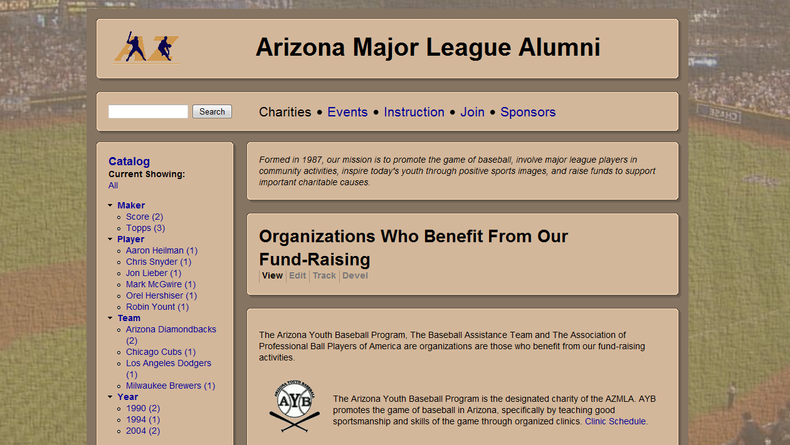

## Architecture

Everything we have done is inside Drupal. The parts we implemented code for was the custom theme, baseball catalog, events calendar, user profiles, and simple baseball card entry. The existing content is a set of nodes that went right into Drupal though it took a lot of configuring to make it work correctly.

### Existing Content

All of the existing content was migrated from the old, disjunct, static, poorly designed website, to the new, uniform, interactive, modern website.

### Theme

Drupal comes with a core set of theme functionality that allowed us to create a completely custom look uniformly across the website.

### Baseball Catalog

The baseball catalog was a module built on Ubercart (the basic store functionality) that allows users to easily browse and find the products they desire.

### Baseball Card Entry

The original product entry page was complex and included unneeded options. We streamlined the entry page, and created a card entry page for our client so he could easily and quickly add baseball cards to the store.

### Configured Modules

We also set up modules for displaying the Calendar and user profiles. You can see how all of these modules fit together below. We successfully built our system using this architecture.

Drupal Core

Drupal Theming Engine

Custom AZMLA Theme

Modules

User Profiles

Events Calendar

Ubercart

Baseball Catalog

Simple Baseball Card Entry

Existing Content

# Usability Testing

We ran basic tests on the system to make sure it acted accordingly. Every bug, or obvious error, was fixed as we encountered them. We probably did too little testing on our solution overall, and never managed to do user testing. Conflicts with how we saw the catalog module working and how the customer wanted it to work resulted in a mixed design which may be simplified later. However, it is important to note that the Catalog module was designed taking into consideration many other successful web-stores. In the end, our web-store is very usable, and a viable product for our customer.

# Conclusion

Our sponsor wanted a solution for selling sports memorabilia online, and we produced a functioning, viable website. The AZMLA has received more than they asked for with our solution; though we were not able to implement every last minute change our client suggested, we are satisfied with our solution and believe the AZMLA is too.